38

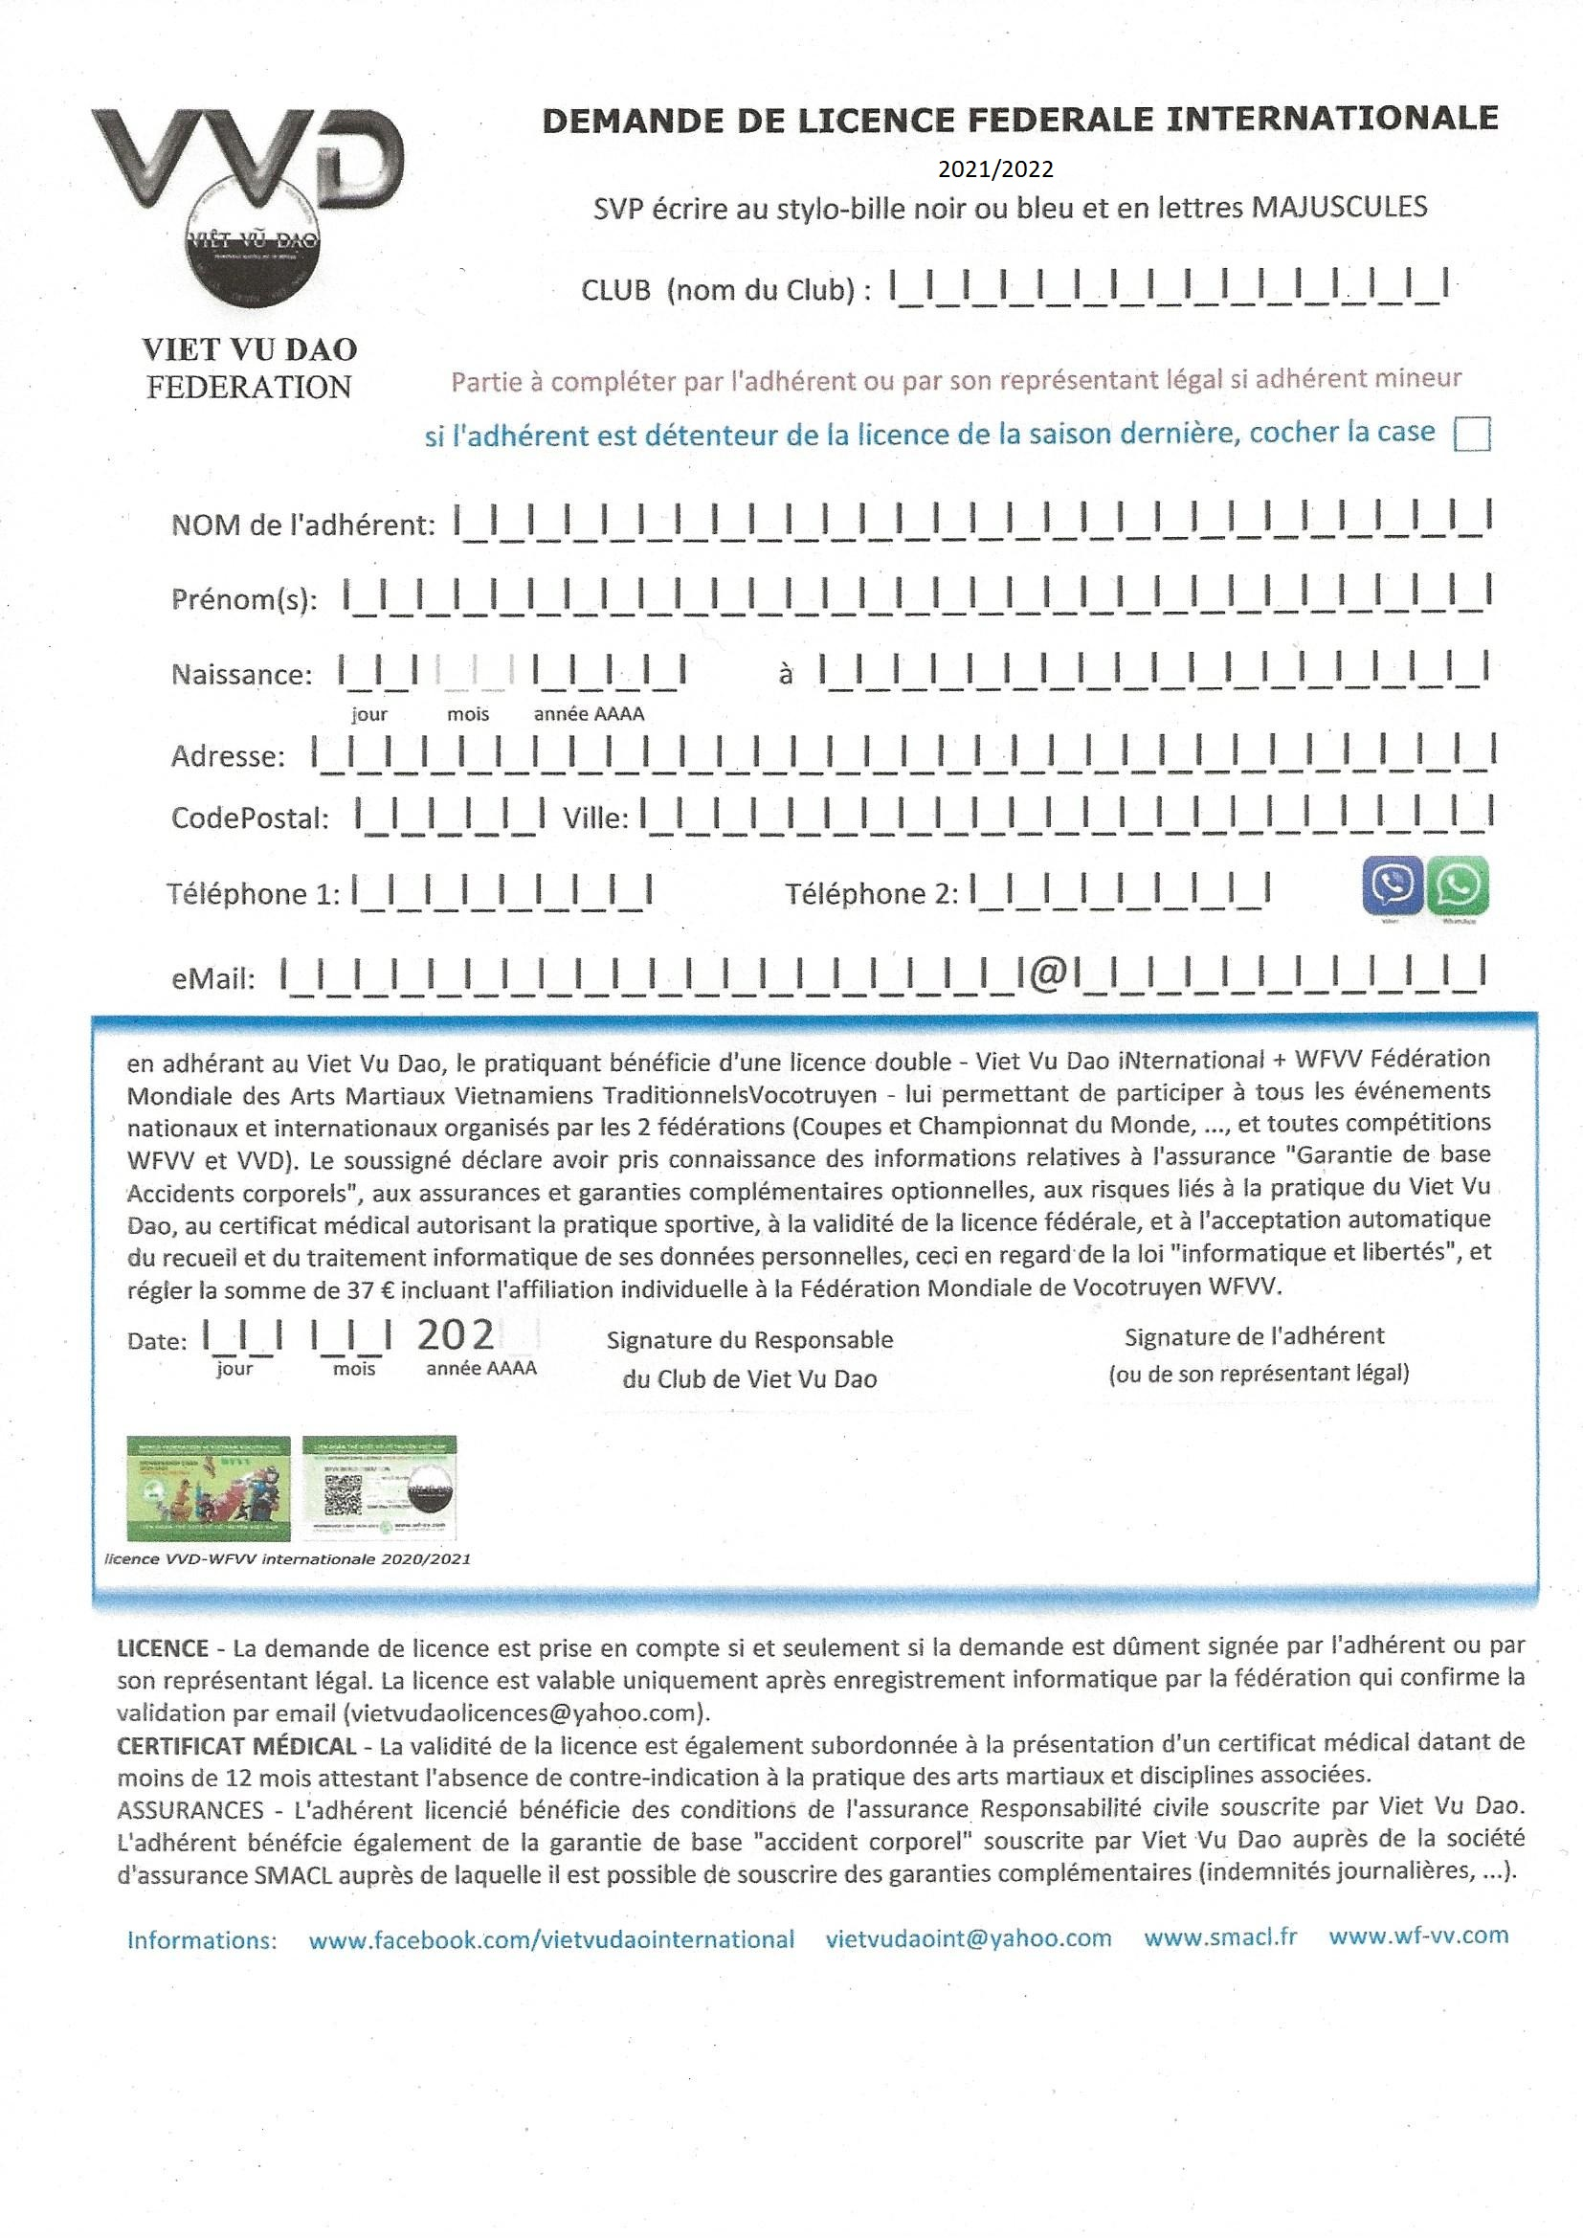

XXXXXXXXXXXX

2022/2023