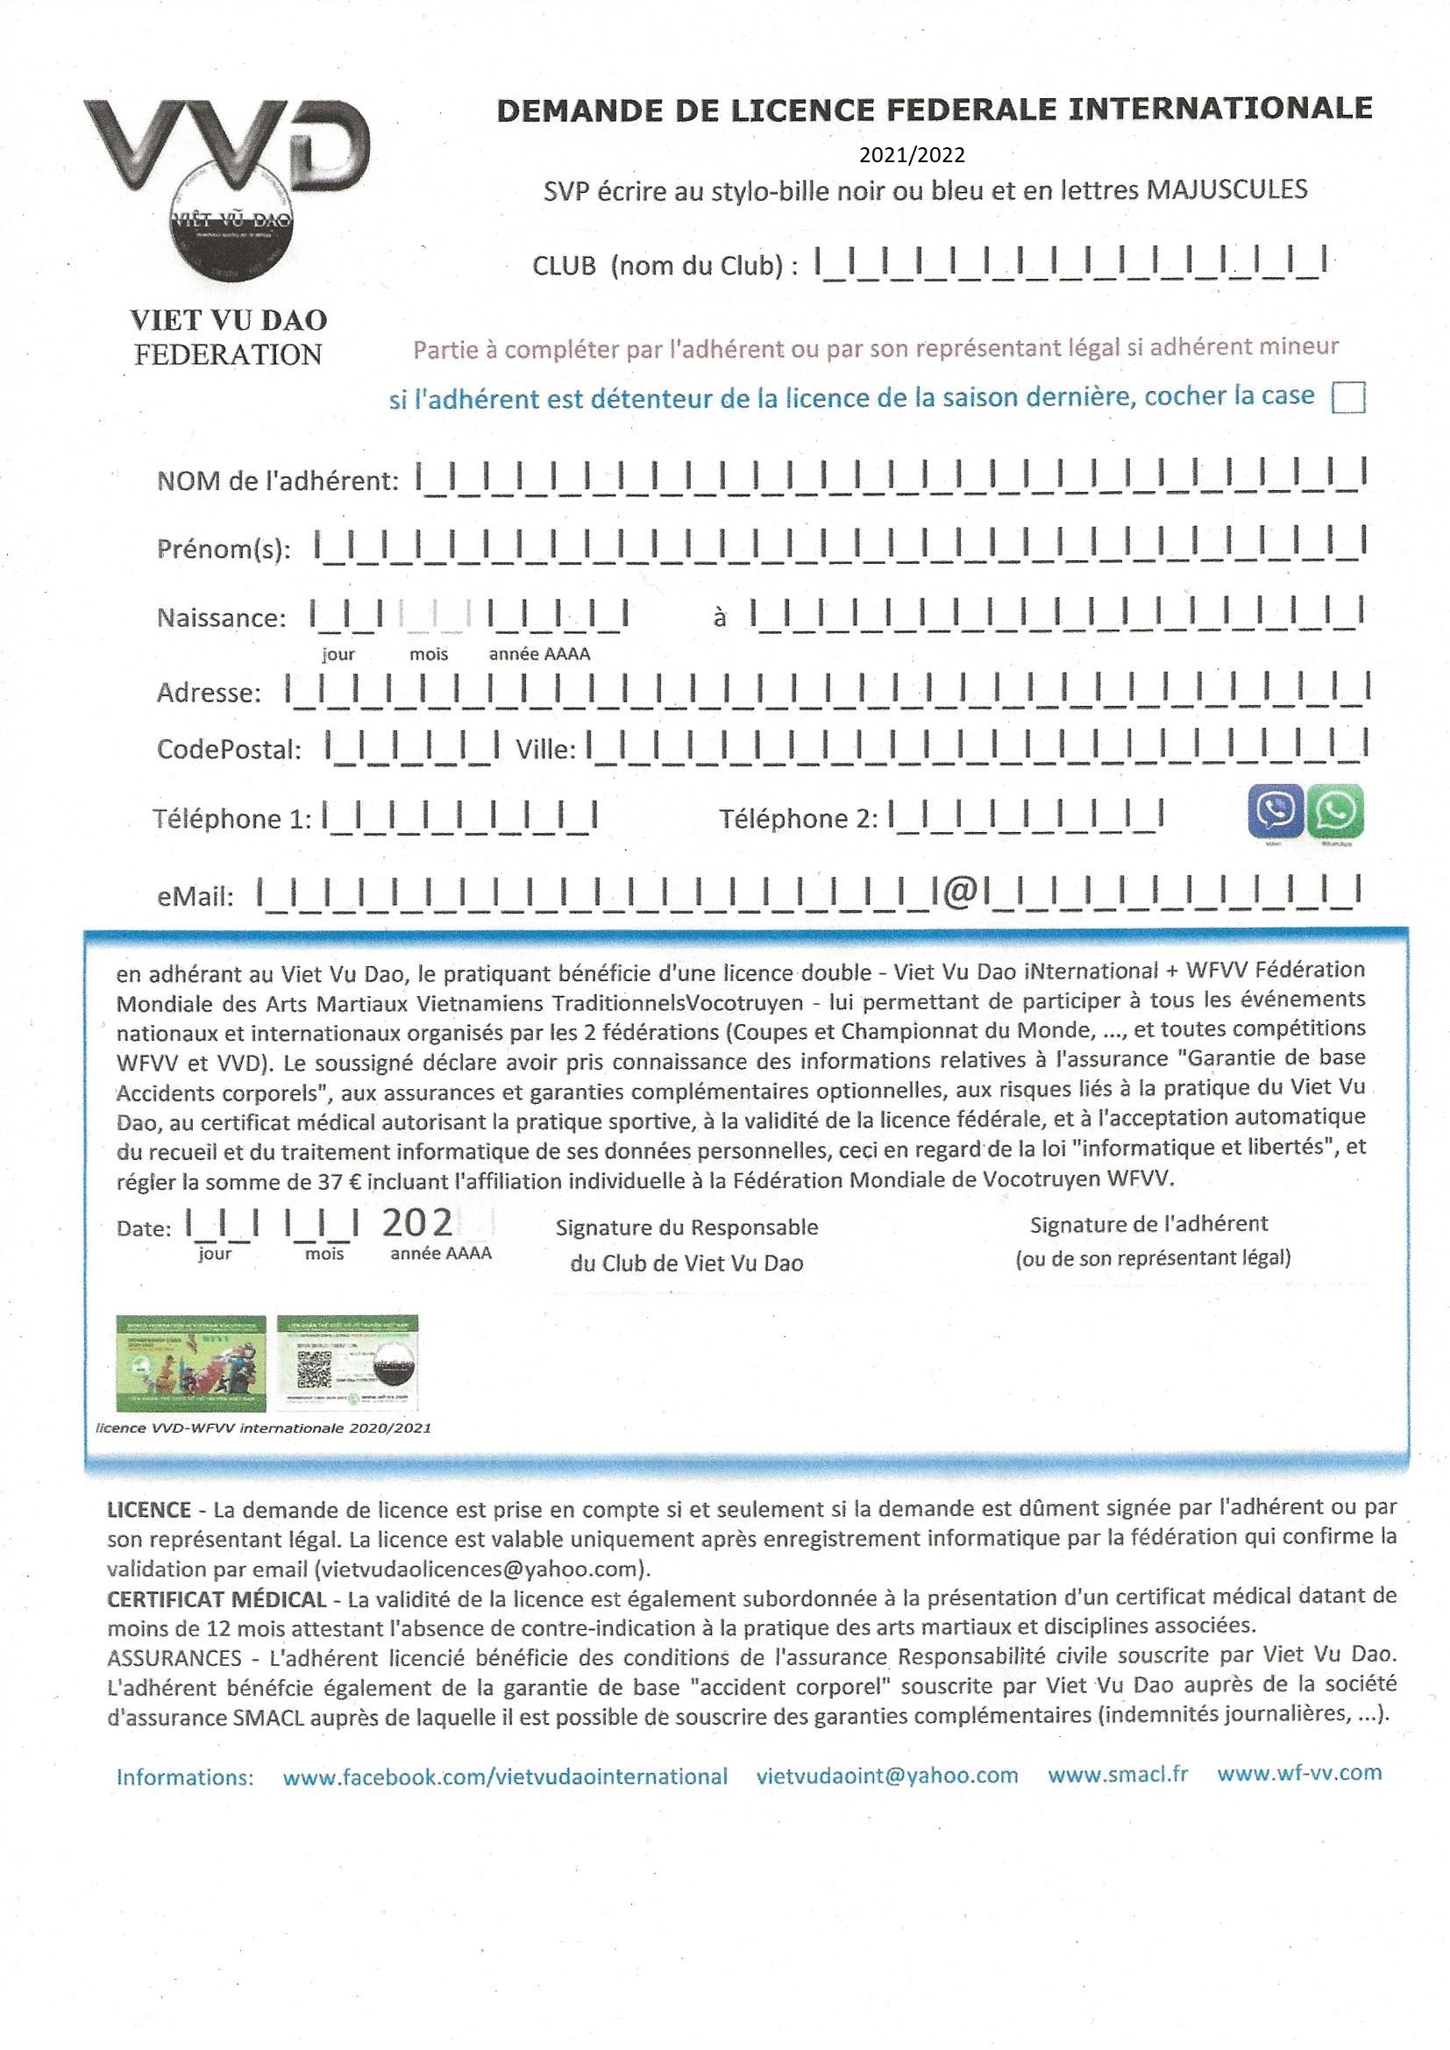
38
XXXXXXXXXXXX
2025/2026

